How to build a garden shed: A metaphor for achieving harmony between career and family
Kathryn Saeb-Parsy¹, Nadia Saeb-Parsy², Kiana Saeb-Parsy³, Kourosh Saeb-Parsy⁴
1 Stephen Perse Foundation Junior School, Union Road, Cambridge
2 Year 4, Stephen Perse Foundation Junior School, Union Road, Cambridge
3 year 5, Stephen Perse Foundation Junior School, Union Road, Cambridge
4 Department of Surgery, University of Cambridge, NIHR Cambridge Biomedical Research Centre, Cambridge
Constructing a garden shed or other building for your family can serve as a useful metaphor for how to achieve harmony between your life and career. Your vision of ‘the perfect family shed’ will likely include key attributes such as the shed’s purpose, design, colour, size, location and structural parts. These can represent a family’s life aspirations such as health, relationships, education, financial security, career achievements, rest and relaxation. Building your family’s perfect shed and achieving harmony between the family’s life and career ambitions both require planning, communication, compromise, resourcefulness and teamwork. Here we examine the similarities and describe how building a metaphorical – or actual – shed can help create and maintain harmony between life and career.
Create a common vision. Seek consensus from everyone in the family about what you plan to build, what it will look like and what it will be used for. Conflict could arise if you want to build a garden shed, while other family members prefer to build a beach hut. In life, conflicts are also likely to arise if, for example, one parent aims to become a world leader in their profession, but this goal is not recognised as a priority by the rest of the family. Achieving a common vision requires open discussion and an acknowledgment that not all goals may be achievable simultaneously: compromise may be necessary from all family members.
Share ownership. The vision of the shed should satisfy the whole family’s desires and directly benefit everyone. If you set out to build a ‘tool shed’ which only meets your needs, it may be difficult to incentivise the whole family to contribute to its build. Similarly, a unilateral decision on the colour of the shed is unlikely to foster a genuine feeling of ownership by the whole family. In life, it is equally important to reach explicit agreements and compromises by everyone about career aims and other family priorities. For example, it may be necessary to discuss the relative priorities of family events against professional meetings and grant application deadlines.
Recognise and value contributions. Make sure everyone actively contributes to building the family shed, no matter how small their contribution may seem at times (figure 1). Everyone should understand that they have an important role and an obligation to contribute to building the shed (figure 2). This means actively identifying and assigning meaningful tasks to everyone based on their capacity, such as painting by the children. In life, it is similarly important to explicitly acknowledge everyone’s contribution to the family’s vision. Doing the school run, for example, would be recognised to be as important as working to submit a grant application, because they are both indispensable for achieving the common family vision. Similarly, school homework or music practice are children’s critical contributions to the family goal.
Prepare for emergencies. Circumstances may require unexpected changes in tasks and priorities. An impending rainfall, for example, may require one person to work longer than anticipated to complete the roof of the shed, thus missing a family event. This would hopefully not result in a ‘family conflict’ because everyone recognises that the extra work is essential to ensure integrity of the family shed. Such difficult and unexpected circumstances can in fact unite the family to better support each other at times of need to deliver the common vision. In life, such an outlook can also help eliminate conflict and disharmony in difficult circumstances. For example, missing sports day due to an over-running critical experiment, or missing an important work meeting because of a delayed school sports fixture, can be more positively managed if the whole family recognises the importance of these activities and is prepared to make allowances for unforeseen circumstances.
Plan and prioritise. You may not be able to achieve all key features of the shed all at once due to time or financial limitations. Discuss and plan these, so that everyone knows their personal needs will be prioritised in due course. With patience, everyone’s turn will come. This will help keep everyone motivated even when they feels the focus of activity does not directly appear to be on their needs. For example, the family may prioritise installing electricity, but agree that future resources will be allocated to gym equipment for the children. Similarly, one parent may take a temporary career break when a new child is born, but the rest of the family will prioritise their professional needs in due course.
Start with a good foundation. Constructing a strong foundation is the critical initial step to building a long-lasting shed. Since the foundations are rarely visible, it can be tempting to save time or resources at this stage. However, a weak or uneven foundation can lead to structural problems in the future. These foundations are the core family values such as trust, honesty, fairness, a willingness to compromise and a fair approach to addressing disagreements and conflicts. Everyone in the family should be aware of these and commit to them unwaveringly. It is important to spend time and energy to develop strategies for addressing challenges before they occur.
Monitor progress and celebrate success. It is not unusual to lose enthusiasm when building a complex shed over a long period. In the face of inevitable and unforeseen challenges, the end result can at times appear unattainably distant. It is important to review progress regularly and be prepared to change the design of the shed through consensus if necessary. To maintain focus and generate positive feedback, it is also important that frequent milestones are included in the build schedule and are celebrated, for example, in a topping-off ceremony. In life, it is similarly vital to punctuate the family’s ultimate aspirations by smaller attainable goals. These facilitate active monitoring of progress and enable a change direction if necessary. Celebrations of these milestones and achievements will help maintain focus, energy and a positive team spirit (figure 3).
Embarking on a journey to build a beautiful and complex shed can be equally exciting and daunting. Those who have built their dream shed may at first glance appear to have had limitless expertise, time and resources at their disposal. Yet with planning, teamwork, dedication and compromise, every family can strive to build their ideal shed. Harmony between family life and ambitious career plans can seem equally challenging. However, the strategy need not be a compromise between a happy family life and a successful career. Rather, the solution can be sparked from an examination of how career aspirations and other family priorities can synergise to ultimately deliver the vision of happiness and contentment that is shared by the whole family.

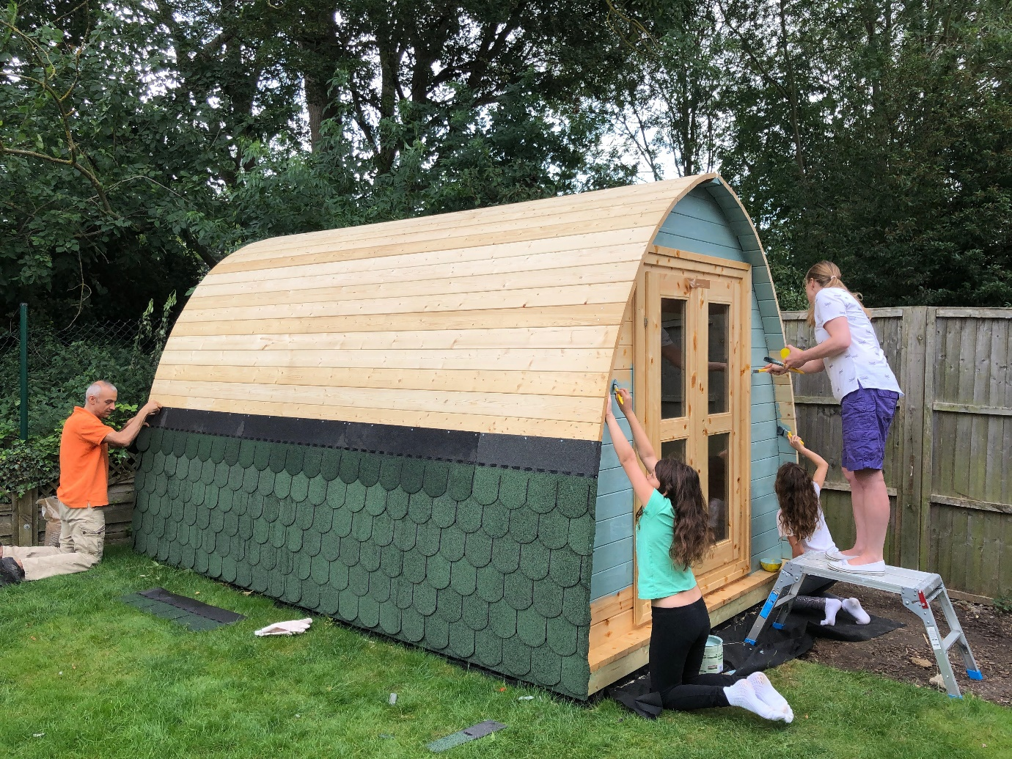
Figure 1: Building the perfect family shed involves the whole family.

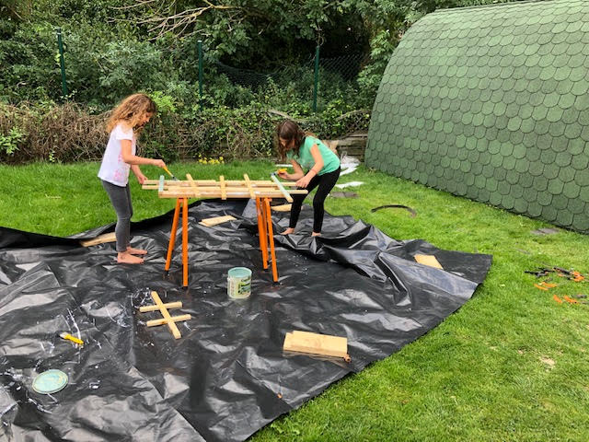
Figure 2. Everyone should be empowered to make a contribution and share ownership of the results.

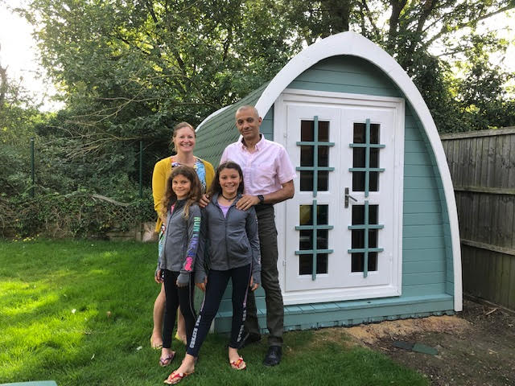
Figure 3. Celebrate milestones and achievements to maintain enthusiasm and drive.

